Room 22 |  |  | October 2021 News
Phys. Ed: Days 1, 2, 3, 4, 5 Music: Days 1, 3, 4 ,6
Library: Day 6

Sunday | Monday | Tuesday |  | Wednesday | Thursday | Friday | Saturday
 |  |  |  |  |  | 1 Day 1 | 2
3 | 4 Day 2 | 5 Day 3 |  | 6 Day 4 | 7 Day 5 | 8 Day 6 | 9
10 | 11  Thanksgiving No School  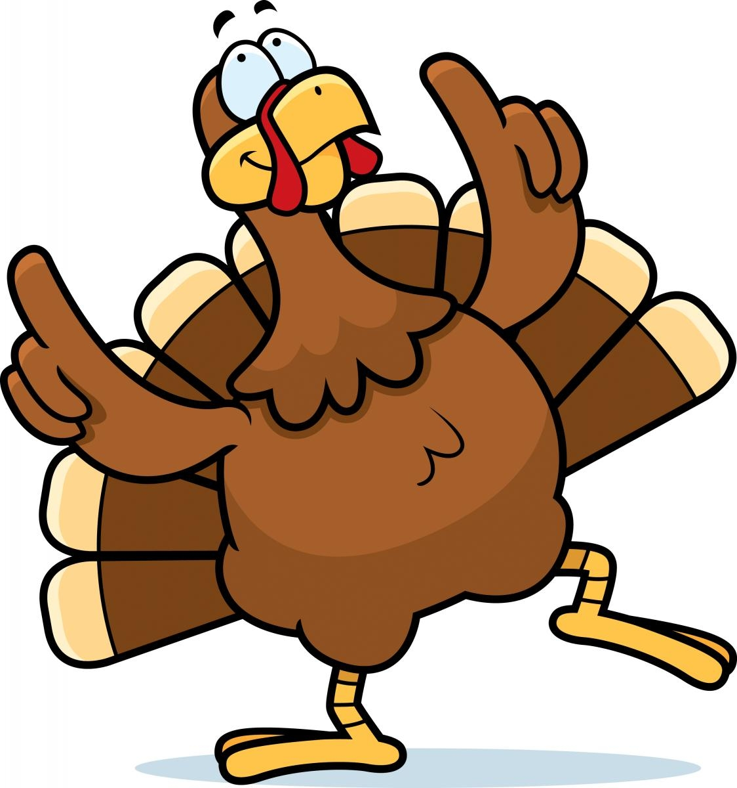 | 12 Day 1 |  | 13 Day 2 | 14 Day 3 | 15 Day 4 | 16
17 | 18 Day 5  P.A.C.  7:00 p.m. | 19 Day 6 |  | 20 Day 1 | 21 Day 2 | 22 Day 3  Inservice Day  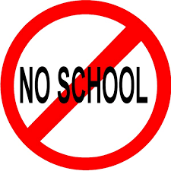 | 23
24 | 25 Day 4 | 26 Day 5 |  | 27 Day 6 | 28 Day 1  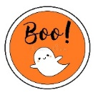  Halloween Party  Parent Teacher Conferences- pm | 29 Day 2  Parent Teacher Conferences | 30
31

Halloween

What’s Happening in Room 22?

To: Parents/ Guardians
From: Mrs. Dewar / bdewar@lssd.ca / www.mrsdewar.weebly.com

During October, the following topics will be covered in our classroom. Please feel free to contact me if you have any questions.

English Language Arts
- Paragraph Writing
- Novel: “Fatty Legs”
- Reading Power: Making Connections
- Status of the Class – conferencing about daily reading
- Spelling

Mathematics
- Continuing Place Value
- Adding and Subtracting Strategies for basic facts
- Adding, Subtracting, and Estimating Strategies for large numbers
- Bar Graphs
- Problem Solving

Social Studies
- Residential Schools
- Oral Traditions
- Provinces and Capitals of Canada

Science
- Properties of and Changes in Substances

Other
- Thank you for reading and signing your child’s planner each night! I appreciate it
- Also, thank you for helping your child to read at home each evening and for sending the Book Bags to school each day!
- Please remember to write any end of the day changes in your child’s planner or contact the office to inform of any pick-up changes. Sending an e-mail or a Seesaw message might not be seen in time.

Halloween Party
- Students are asked to come to school dressed in their costumes or be able to put them on in the classroom.
- Face masks will still need to be worn. Costume masks do not take the place of non-medical masks.
- All costume "props" should be left at home.
- Please note that there will not be a Halloween Parade, instead we are having a “Virtual Parade” so we can see each other’s costumes!
- Students can pack an extra snack for the party. Due to Covid protocols, students will not be allowed to bring treats to share. I will provide a small, pre-packaged treat for students

